**1. Phase report**

a. Group member

Zihao Wang， 110794512

Haofeng Liang 111405314

Yingnan Li 111149515

b. Environmental information

* **Database:** mysql
* **Front-end**: html
* **Back-end**: JDBC

c. Transactions description

1）home page

Introduction: In the very begining page, user can choose to either login as candidate or employer, or register as candidate or employer.

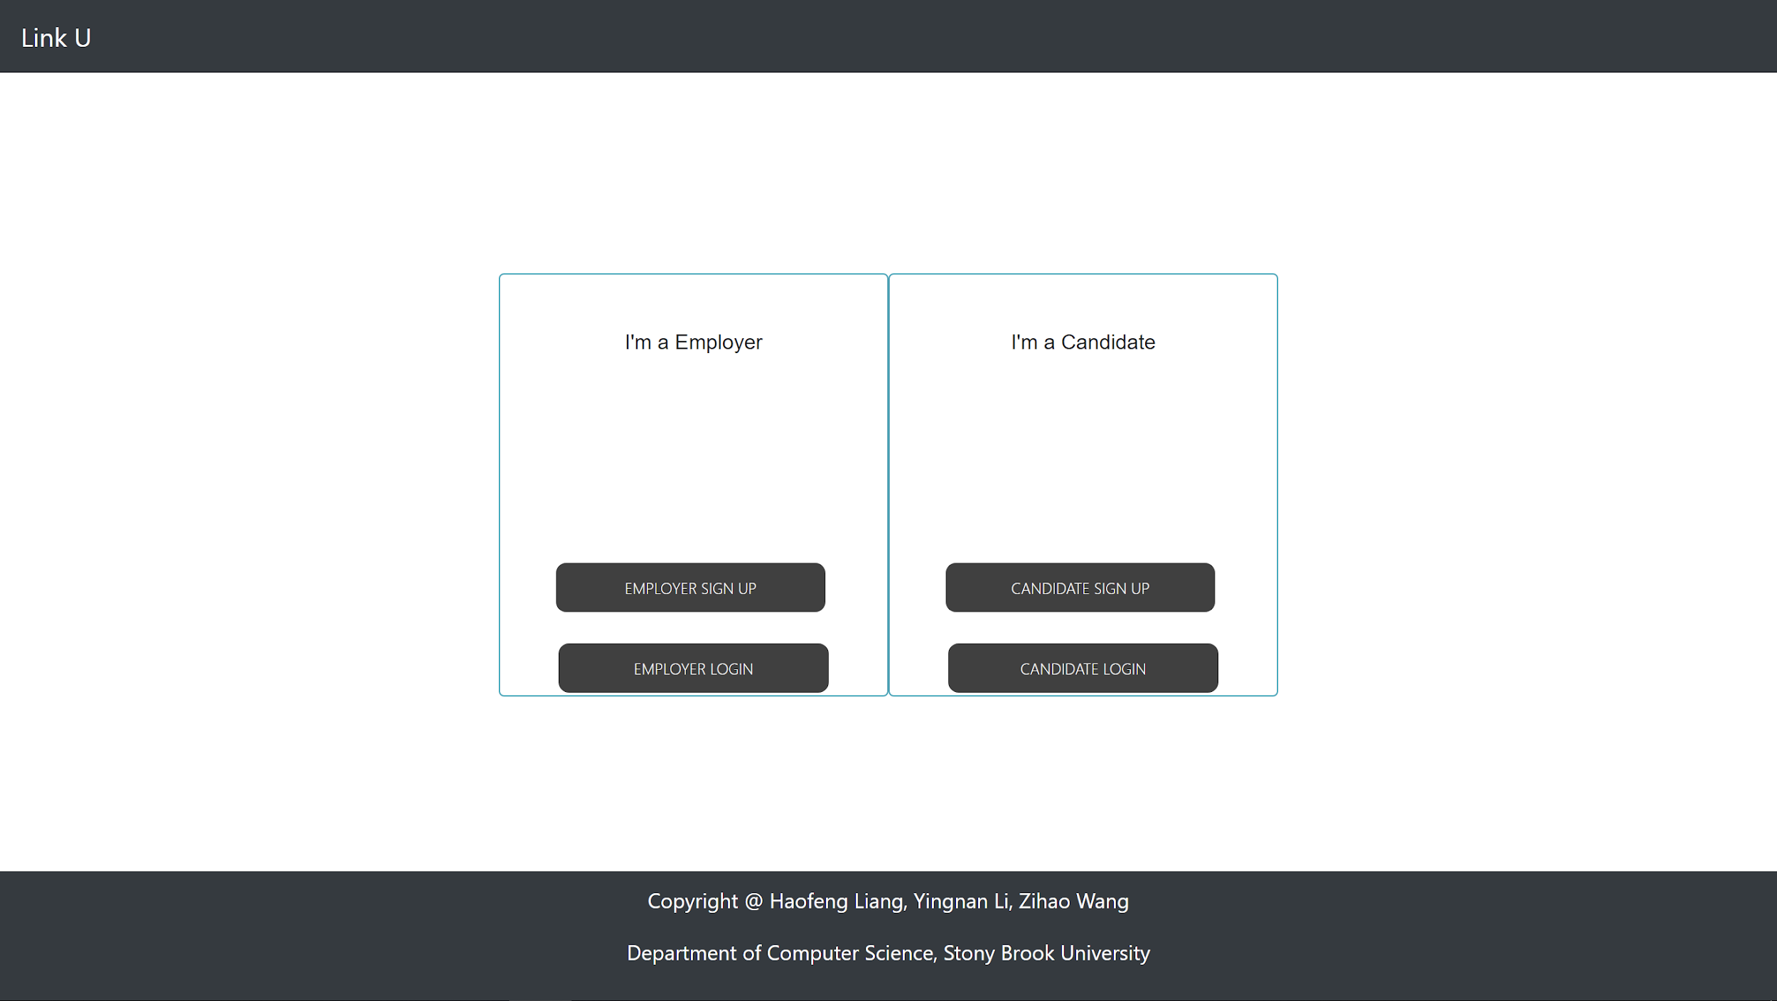

2)Employer Register(sign up)

Introduction: After clicking either the “EMPLOYER SIGN UP”, users come to the register page for them. Here the employer is asked to fill in the information such as company name, CEO, etc. After filling out the information, the employer clicks the “Sign up” button. After that, a transaction that adds a new employer record to the database’s employer table is executed. At the same time, the browser jumps to a feedback page telling the user that he has successfully registered,

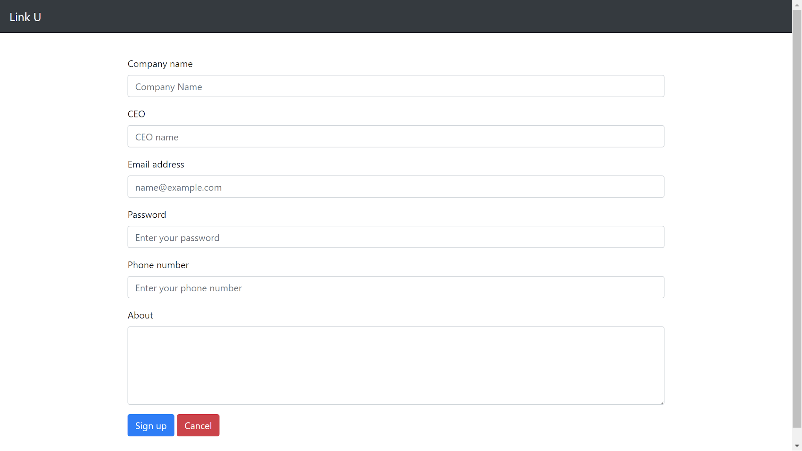

3)Candidate Register(sign up)

Introduction: Almost the same with 2)Employer Register(sign up). A transaction that adds a new candidate record to the database’s candidate table is executed.

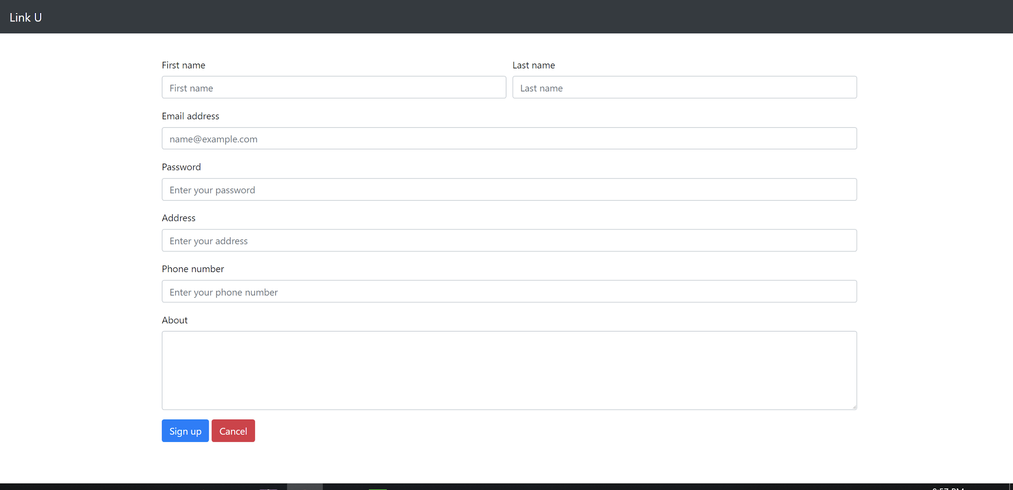

4)Employer Login

Introduction: After clicking the “EMPLOYER LOGIN” button on home page, user is led to Employer Login page where user is asked to fill in ? . After that, the employer is transferred to the 5)Employer-List job page.

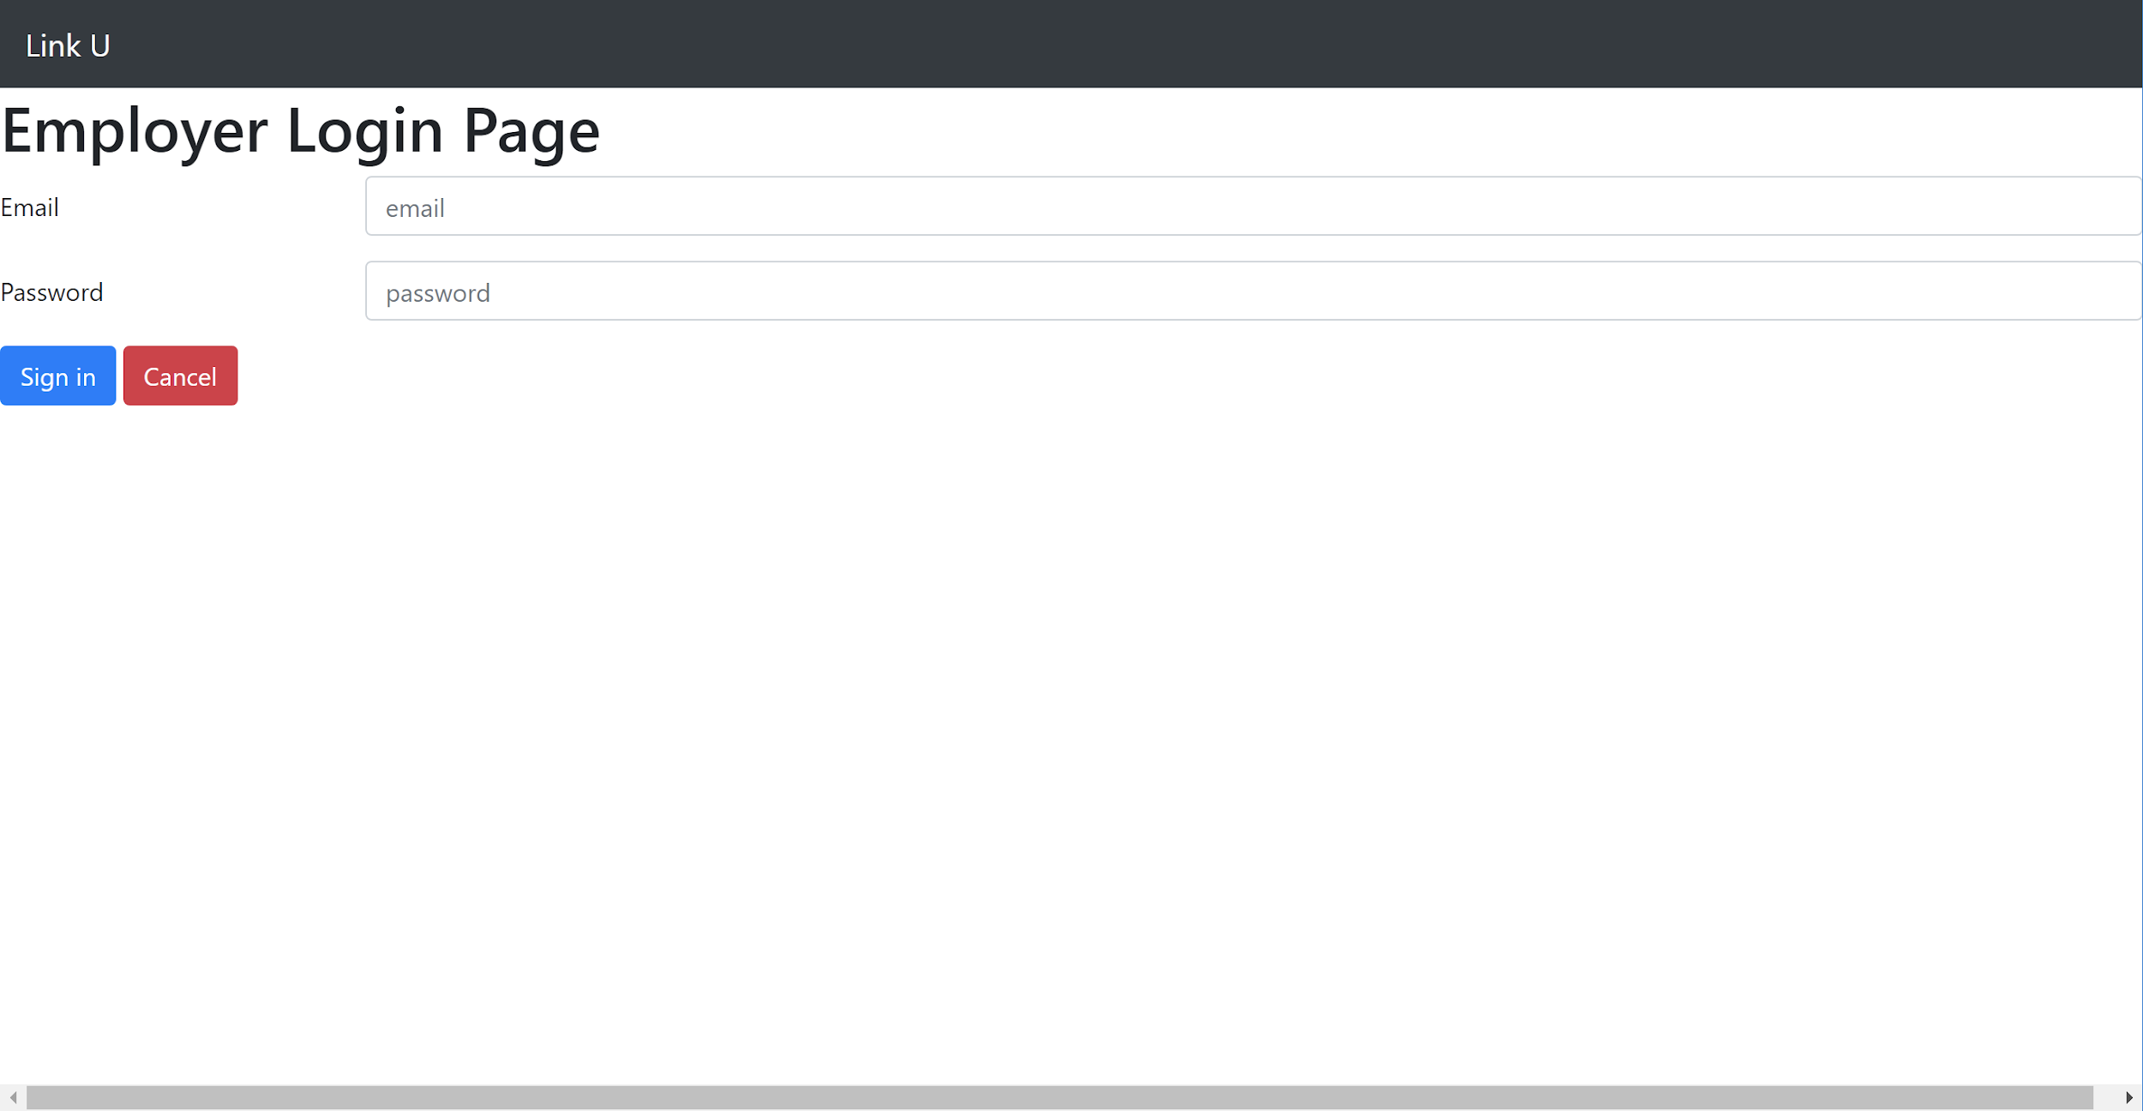

5)Employer-List Job

Introduction:

When the employer comes to this page, a transaction that selects all the job records of this employer is executed and then this page lists all the jobs that the employer provides. Employer can add a new job by clicking the “+” button which jumps to the 6)Employer-Add Job page, or deleting an already-existed job by clicking the “Delete” button on its right which executes the transaction that removes this job record from the database.

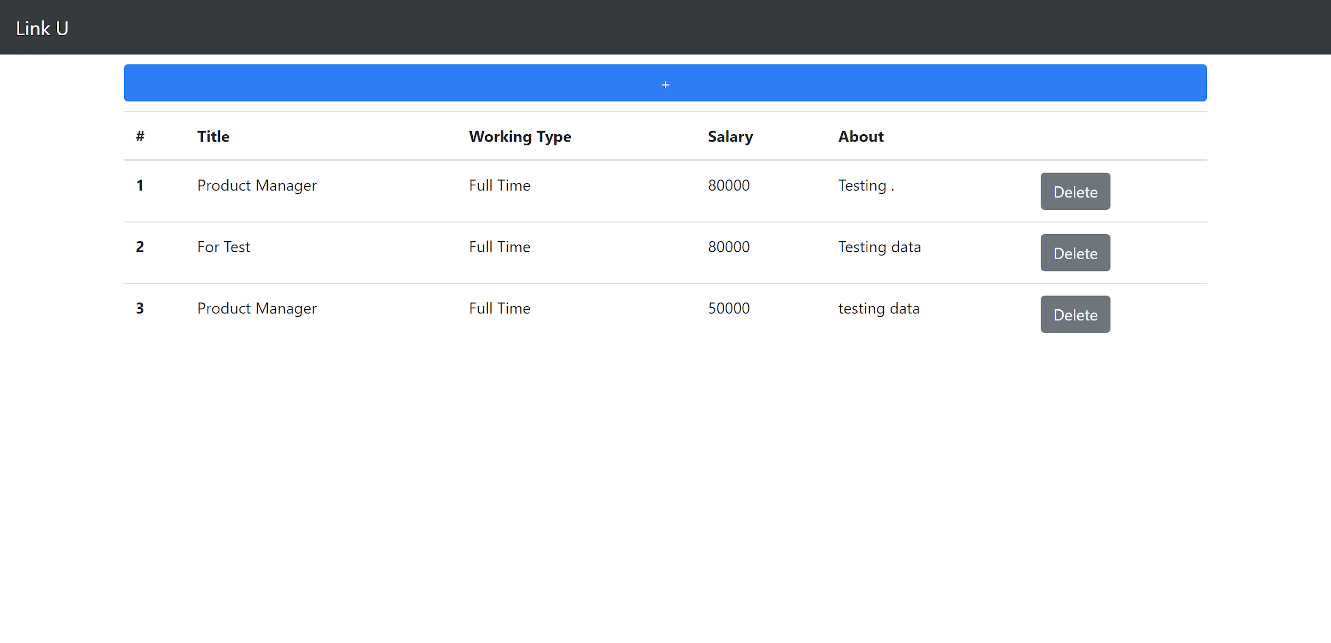

6)Employer-Add Job

Introduction: In this page, the user is required to fill in the added job’s information including job title, salary, etc. And then the user clicks the “Add” button which executes the transaction that adds the job to the database.

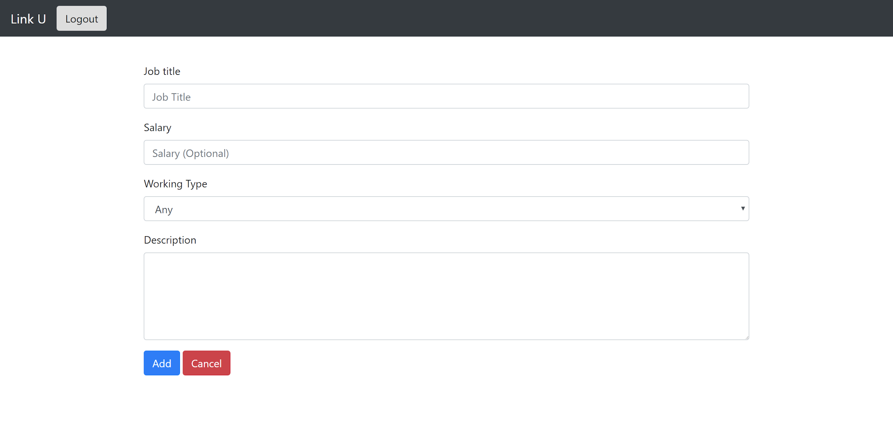

7)Candidate Login

Introduction: After clicking the “CANDIDATE LOGIN” button on home page, user is led to Candidate Login page where user is asked to fill in ?. After that, the candidate is transferred to the 8)Candidate-Search job page.



8)Candidate-Search job

Introduction: In this page candidates can search for jobs based on the job title or company name they provide. A transaction that selects all the jobs that satisfy the conditions is executed, and then the result job set is listed in the page.

